1. File Management:

Write a script that takes a directory path as input and creates a new directory within it named "Backups_$(date +%Y-%m-%d)".

Create a script that renames all files in a directory with the extension ".txt" to have a prefix of "report_".

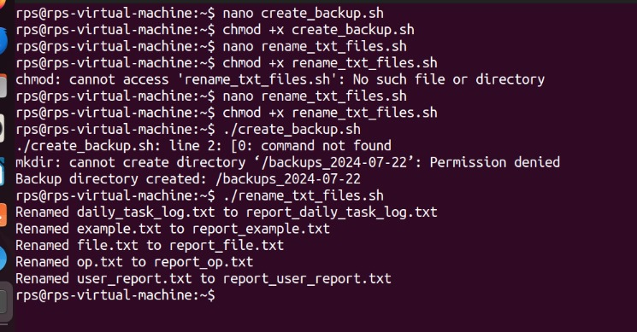

2. User Interaction:

Write a script that prompts the user for their name and age, then greets them with a personalized message.

Design a script that displays a menu with options like "List files," "Create directory," and "Exit." Allow the user to choose an option and perform the corresponding action.

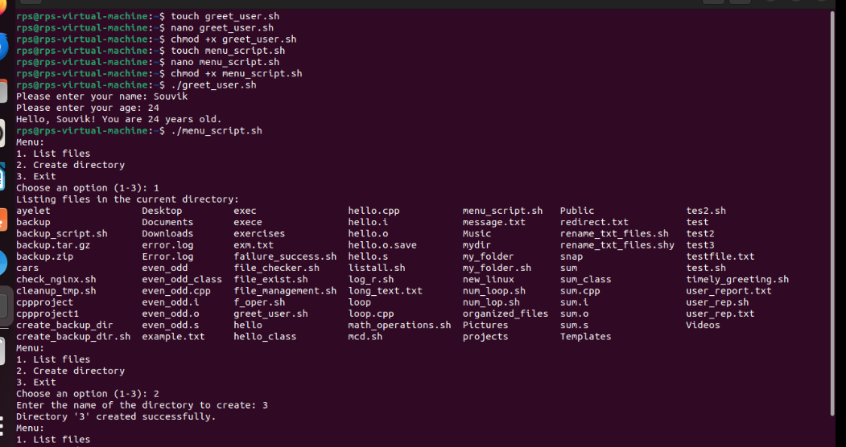

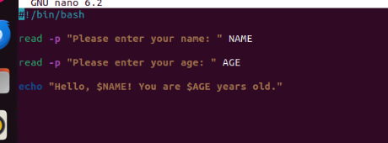

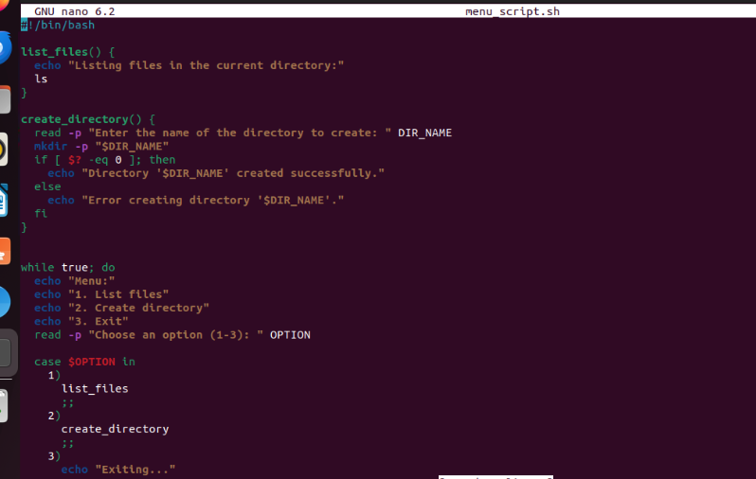

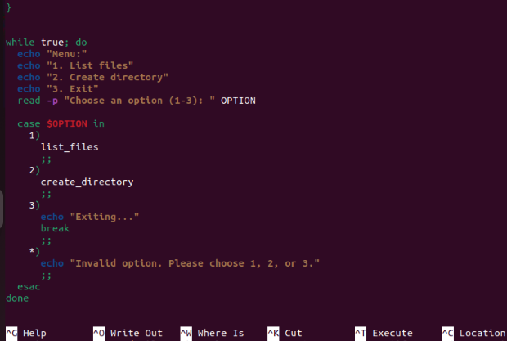

3. Text Processing:

Write a script that reads the contents of a file line by line, counts the number of lines, and prints the total.

Create a script that takes a text file as input and replaces all occurrences of a specific word with another word.

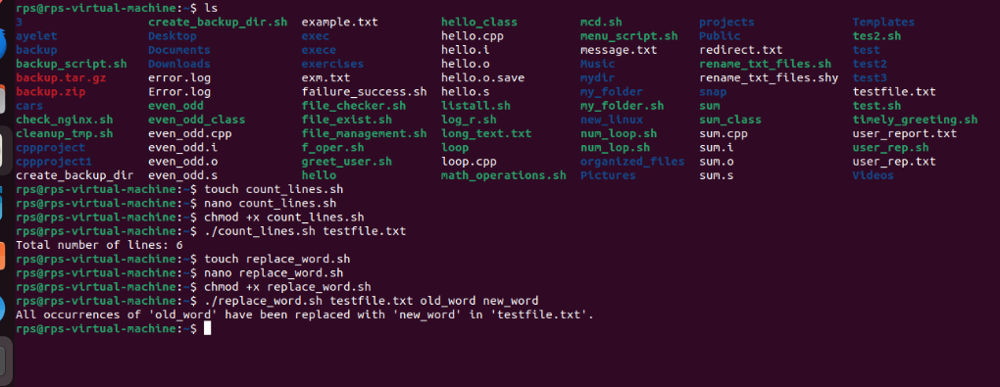

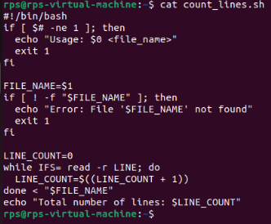

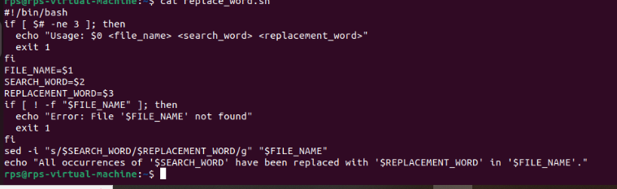

4. System Administration:

Write a script that checks if a specific package is installed and, if not, installs it using the appropriate package manager (e.g., apt-get, yum).

Create a script that monitors disk usage and sends an email notification if it exceeds a certain threshold.

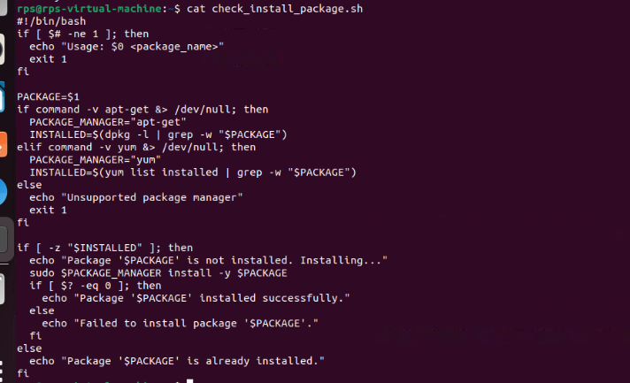

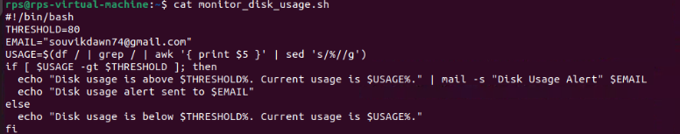

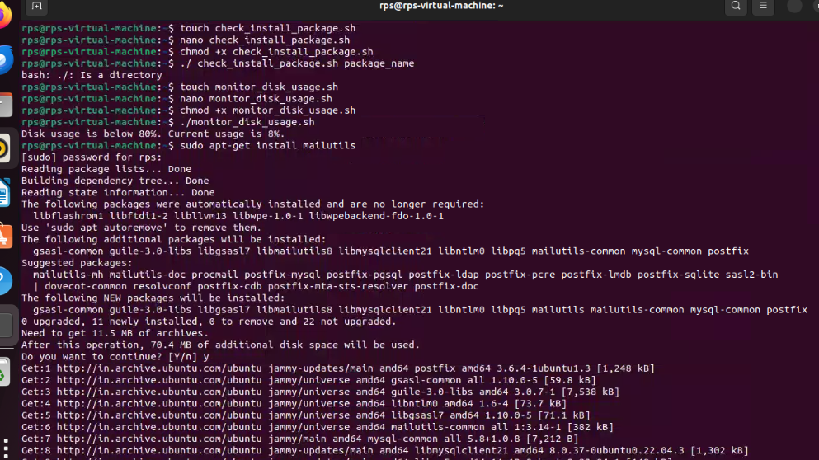

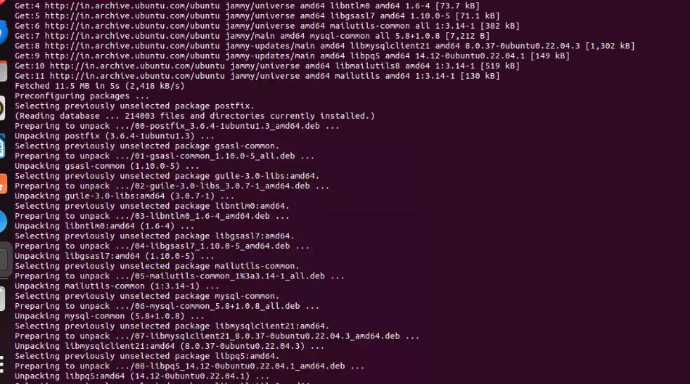

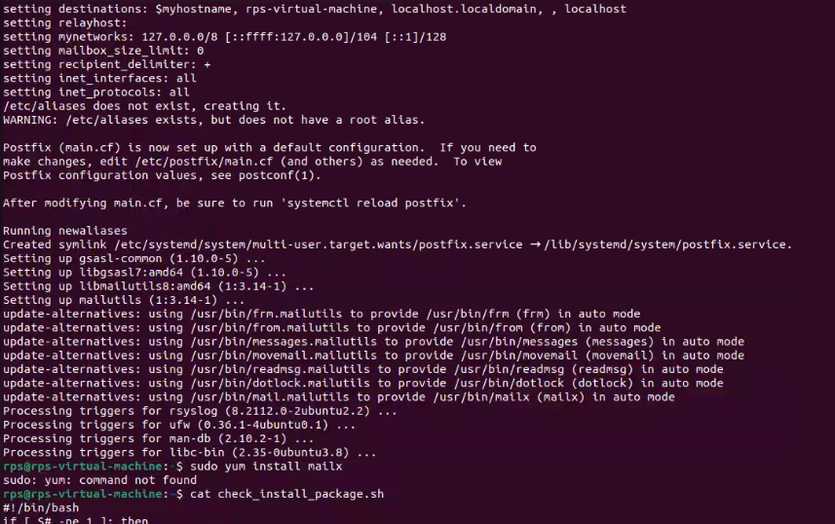

5. Data Manipulation:

Write a script that reads a CSV file, calculates the average of a specific column, and prints the result.

Create a script that generates a random password of a specified length, meeting certain criteria like uppercase, lowercase, numbers, and symbols.

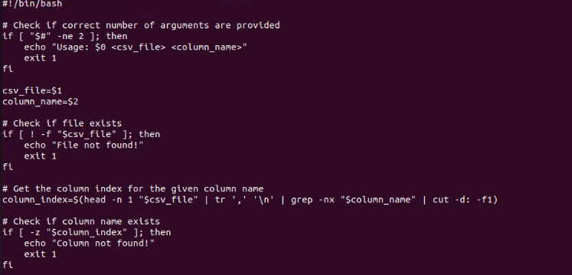

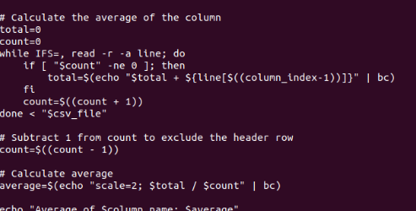

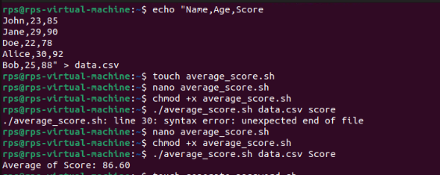

Part 2:

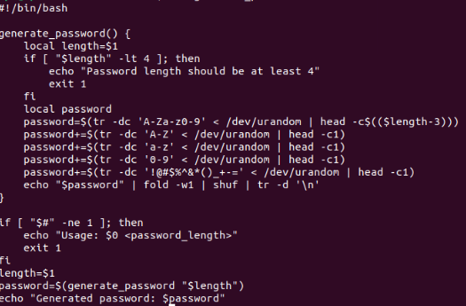

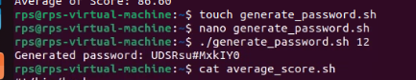

Write a script that pings a list of servers and reports if any are unreachable.

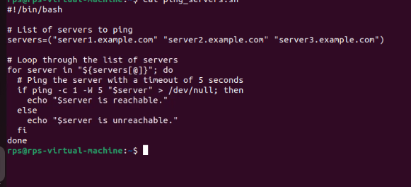

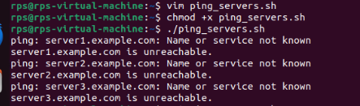

Create a script that backs up a remote directory on another server to a local directory using tools like scp.

